Ansible Playbook, to deploy a static app(apache) on ec2 instance using Ansible.

vim playbook.yaml

vim inventory.ini

vim index.html

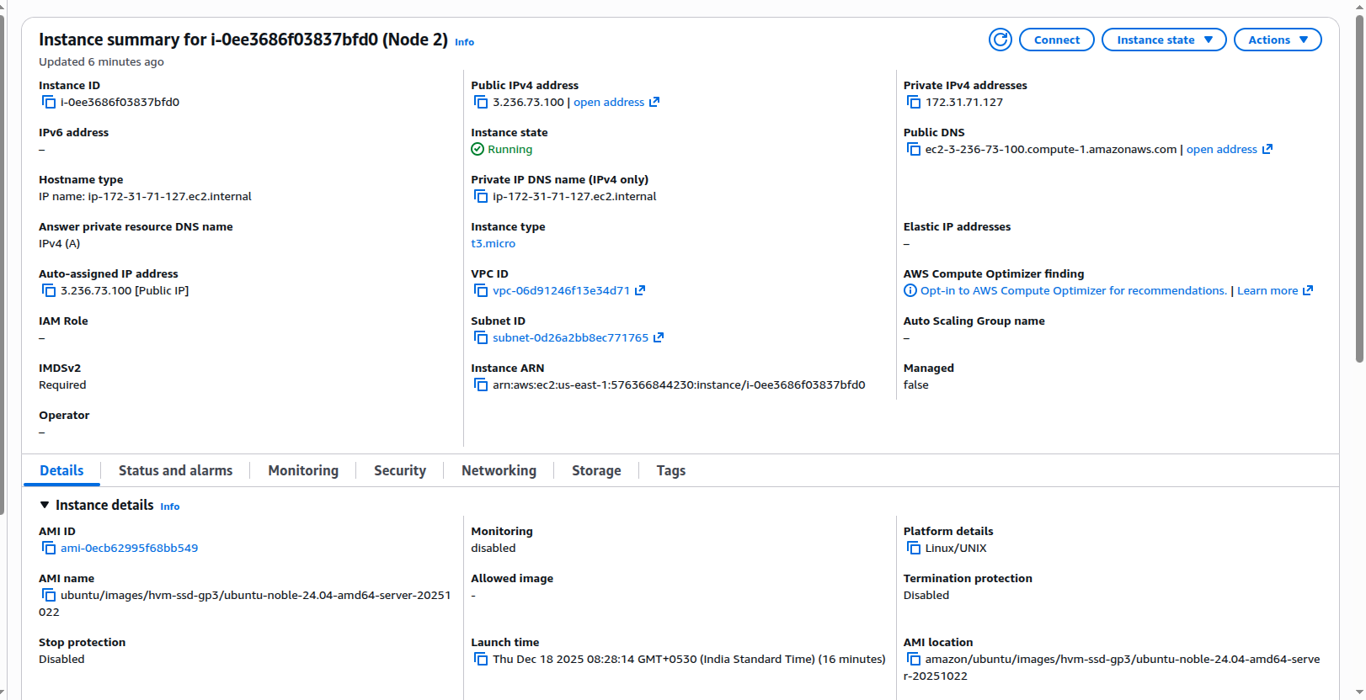

ansible-playbook -i inventory.ini playbook.yaml

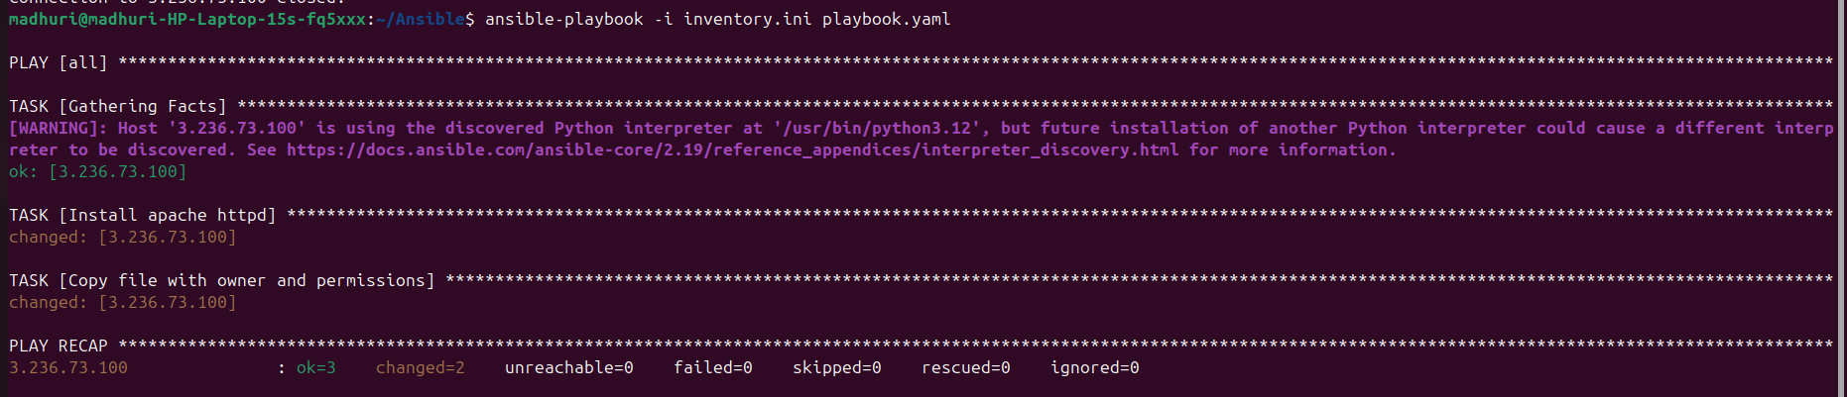

sudo systemctl status apache2

